**ARRAYS AND POINTERS**

**1. What does the code below refer to? Extend the code and demonstrate the use of ptr to access the contents of a 2D array.**

**int (*ptr)[4];**

**[Refer the sample code in “array_ptr_simple.c”]**

**OUTPUT:**

**2. Refer the code in “array_ptr_simple_char.c”. Implement the missing functionality in the code marked with TBD1, TBD2…..**

**3. Refer the code snippet below. Implement the function search_insert() as mentioned in the code.**

**#define MAX 80**

**//search for the given char and if found, then create space for 1 character and insert ‘_’ after the searched character. Let the remaining characters in the input be placed after ‘_’.**

**int search_insert(char name[], char search_char);**

**int main()**

**{**

**char name[MAX]=”ABC”;**

**char *ptr = name;**

**int ret = search_insert(name, search_char);**

**if (ret == SUCCESS)**

**{**

**//display updated string**

**}**

**}**

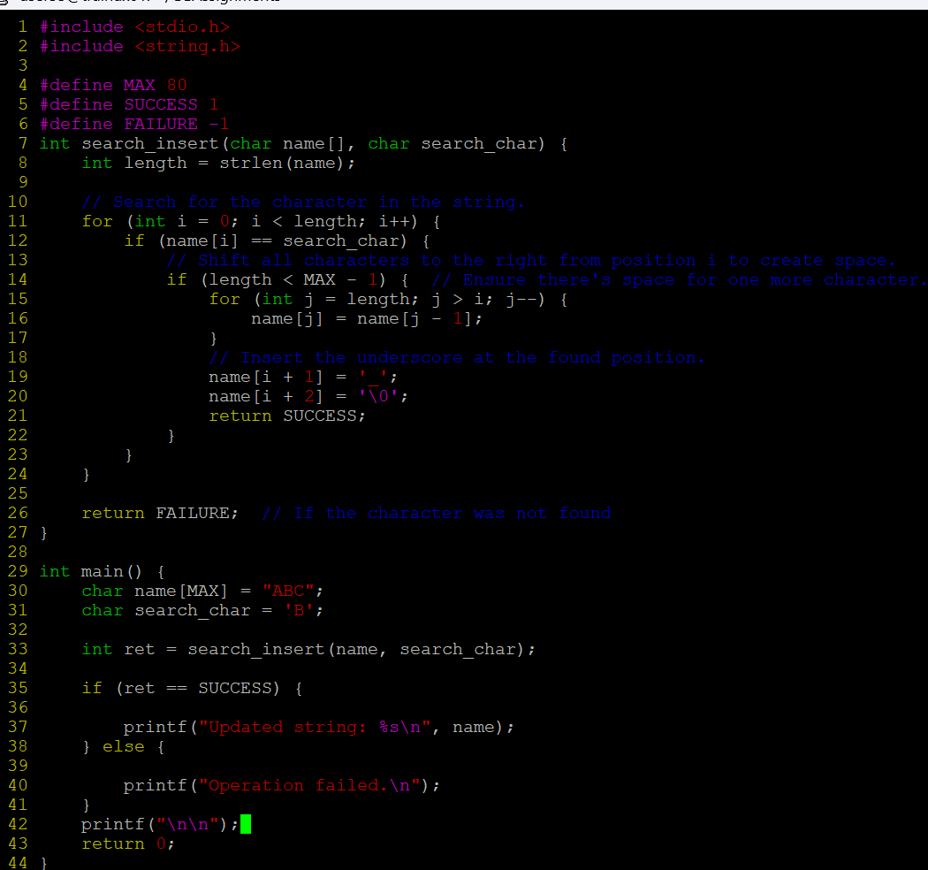

**OUTPUT:**

**4. Refer the program “array_ptr_repr_partial.c”. Implement the functions below which are yet to be implemented in code.**

**int func1(int (*ptr)[3]); // pointer to array, second dimension is explicitly specified**

**int func2(int **ptr); // double pointer, using an auxiliary array of pointers**

**5. Refer the program “array_dbl_pointers_function_partial.c”. Implement the missing functionality in the code marked with TBD1, TBD2…..**

**6. Refer the program "pointer_example.c". Fix the warning issue.**

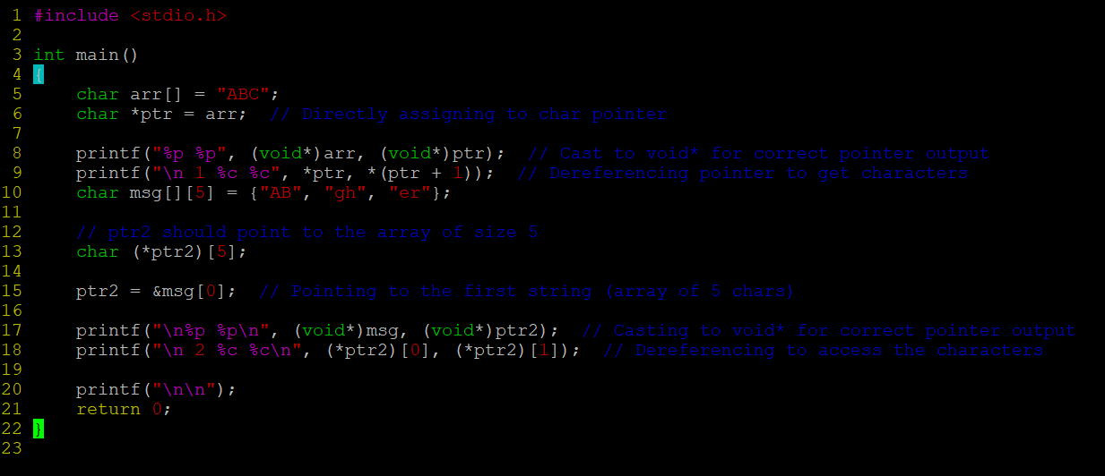

**OUTPUT:**

**7. Consider an array of strings as below.**

**char arr[][10]={"Word", "Excel", "PowerPoint", "Pdf", "Paint"};**

**a. Implement a function read_displaystring() to read a row index from the user, access the string, store in a char * variable and using this, traverse every alternate character in the string and display in console.**

**void read_displaystring(char *arr[][10], int row);**

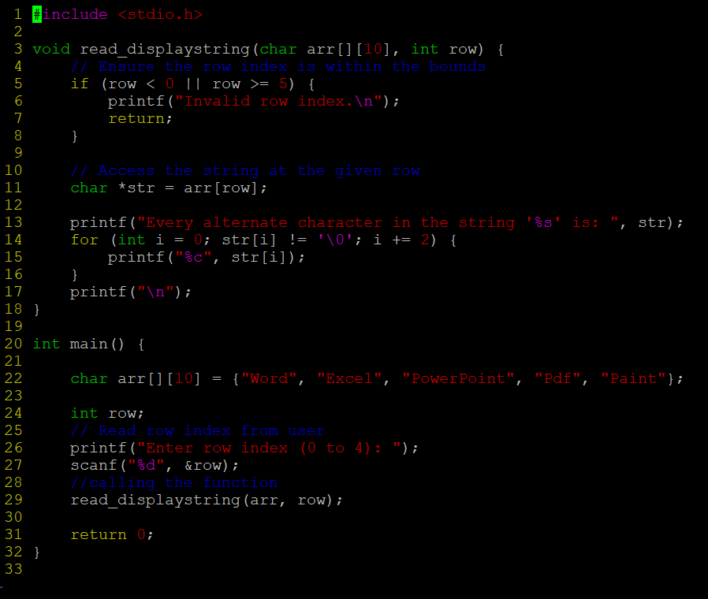

**OUTPUT:**



**b. Reverse the string read at the index in a) using a function of prototype as below. Caller to read the returned string and display the reversed string. [Ensure that the input source array is not corrupted and remaining elements are intact]**

**char *reverse(char *arr[][10], int row);**

**OUTPUT:**

